FIRST WEEK ASSIGNMENT

Boddeboina Chandrasekhar
AP25110010706

1.
#include<bits/stdc++.h>
using namespace std;

int linear(int a[],int s,int n){
for(int i=0;i<n;i++){
if(a[i]==s)
return i;
}
return -1;
}
int main(){
int n;
cout<<"enter size of the array :";
cin>>n;
int arr[n];
cout<<"enter elements into the array :";
for(int i=0;i<n;i++){
cin>>arr[i]; }
int s;
cout<<"enter element to be search :";
cin>>s;

linear(arr,s,n)!=-1?cout<<"element is fount at "<<linear(arr,s,n):cout<<"element is not found";
}

Output:

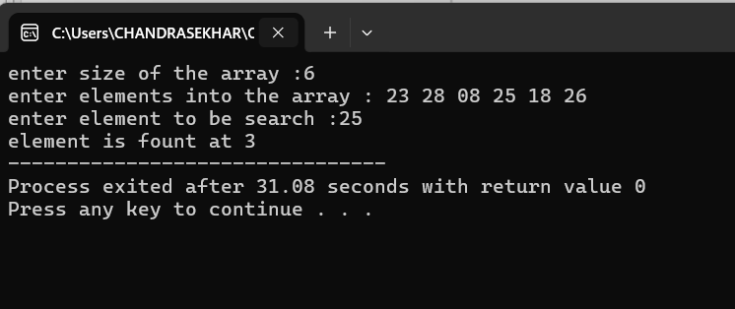
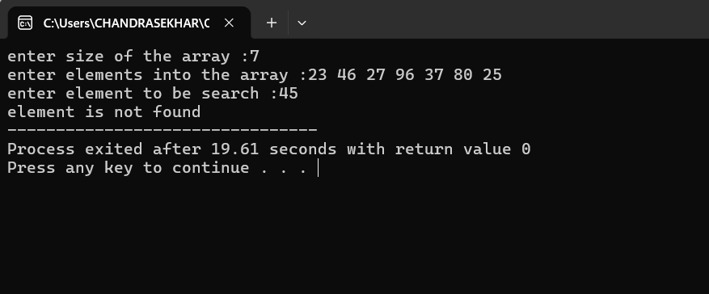

2.

#include<bits/stdc++.h>
using namespace std;

int binary(int a[],int s,int n){
int l=0,r=n-1;
while(l<=r){
int mid=l+(r-l)/2;
if(a[mid]==s)
return mid;
else if(a[mid]>s)
r=mid-1;
else if(a[mid]<s)
l=mid+1;
}
return -1;
}
int main(){
int n;

cout<<"enter size of the array : ";

cin>>n;
int arr[n];
cout<<"enter elements into the array : ";
for(int i=0;i<n;i++){
cin>>arr[i];
}

int c=1;
cout<<"continue this search only if array is sorted. to continue enter 1 if not enter 0. : ";
cin>>c;
if(c==0){
return 0;
}
int s;
cout<<"enter element to be search :";
cin>>s;

binary(arr,s,n)!=-1?cout<<"element is fount at "<<binary(arr,s,n):cout<<"element is not found";

return 0;
}

Output:

